|  |  |
| --- | --- |
|  | **Online Grocery Store**  **Technical Design Document** |
| |  |  |  |  | | --- | --- | --- | --- | |  | **Prepared By / Last Updated By** | **Reviewed By** | **Approved By** | | **Name** | Dighe Riya  Marrivada Shanmukha Sai Kavya  Sumanth Mittapally  Teja Jami  Vaibhav Shetty |  |  | | **Role** | Software Developer |  |  | | **Signature** | Dighe Riya -2065747  Marrivada Shanmukha Sai Kavya – 2065919  Sumanth Mittapally-2065743  Teja Jami - 2066007  Vaibhav Shetty - 2065774 |  |  | | **Date** | 12-01-2022 |  |  | |

Table of Contents

1.0 Introduction 3

1.1 Purpose of this document 3

1.2 Project overview 3

2.0 Solution Summary 3

2.1 Scope 4

2.2 Assumptions 4

2.3 Dependencies 4

2.4 Risks 4

3.0 Schematic Diagram 4

4.0 System Design 5

4.1 Proposed design 6

4.2 Component inventory 7

5.0 Database Design 7

5.1 Data Model 8

5.2 Tables Structure 8

6.0 Appendices 10

6.1 Glossary 10

6.2 Other 10

7.0 Terms & Conditions 11

8.0 Change Log 11

# Introduction

## Purpose of this document

The purpose of this document is to document the technical design, component details and Database design. This will also capture the scope, assumptions, risk, dependencies of this project.

## Project overview

Online Grocery Store application will have different categorization of items for the ease of customers to shop. Customer will register in the application and move the item to the cart. It lists the items in order of price so that customer can choose the cost efficient ones. The customers can choose the time of delivery. Based on the available delivery time the product will be delivered. Online Grocery Store will also show the status of delivery.

**Key Features:**

* New users will be given a Login Id after registration for further use.
* The user’s searching grocery items will display be displayed as per category.
* Convenience of shopping sitting on the couch at home.
* Direct payment can be made to the service provider also Online payment can be made
* Feedback input from the users will consider for further reference.

# Solution Summary

## Scope

**Admin:**

* The admin needs to log in to access the application.
* Admin can modify and manage as per requirements.
* Admin can track the status of the orders.
* Admin is going to get Feedback from Customers.

**User:**

* People who want to use the application will sign up for the application. It can be anyone from the public.
* The user should log in to use the application and place the order.
* The user will be able to change the details of who signed up for the application.
* Users who are logged in to the application can place an order for their orders.
* The user can view the status of the orders.
* As a user, they should be able to cancel the order.
* The user should be able to pay the amount for the Product.
* The user should be able to pay the amount for the Product.

## Assumptions

* User’s data will be viewed only by the admin.
* Users must have a stable and proper internet connection to access the website.

## Dependencies

*<This sub-section shall state the dependencies for this project>*

## Risks

* Due to current pandemic, the grocery items may not be delivered to the user in case of full lockdown.
* Application should not go down even though large number of users are accessing the platform at a time

# Schematic Diagram

A schematic, or schematic diagram, is a representation of the elements of a [system](https://en.wikipedia.org/wiki/System) using abstract, graphic [symbols](https://en.wikipedia.org/wiki/Symbol) rather than realistic pictures. It gives an overview of overall system

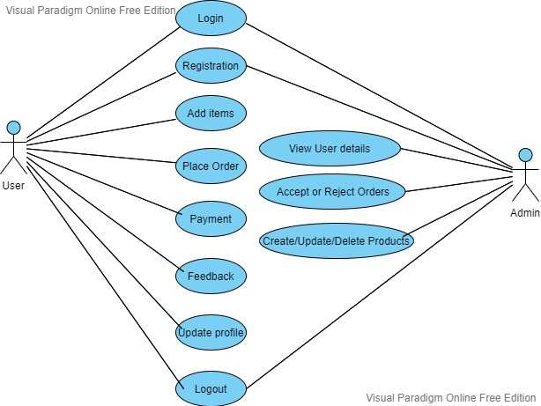

# System Design

## Proposed design

#### Physical Architecture:

A physical architecture is an arrangement of physical elements, (system elements and physical interfaces) that provides the designed solution for a product, service, or enterprise. It is intended to satisfy logical architecture elements and system requirements. Contract Management System follows a three layered architecture namely presentation layer, business logic layer and data access layer.

* **Presentation Tier** is the tier in which the users interact with an application. Presentation Tier contents Shared UI code, Code Behind and Designers used to represent information to user.
* **Business Tier** is mainly working as the bridge between Data Tier and Presentation Tier. All the Data passes through the Business Tier before passing to the presentation Tier. Business Tier is the sum of Business Logic Layer, Data Access Layer and Value Object and other components used to add business logic.
* **Data Tier** is basically the server which stores all the application’s data. Data tier contents Database Tables, XML Files and other means of storing Application Data.

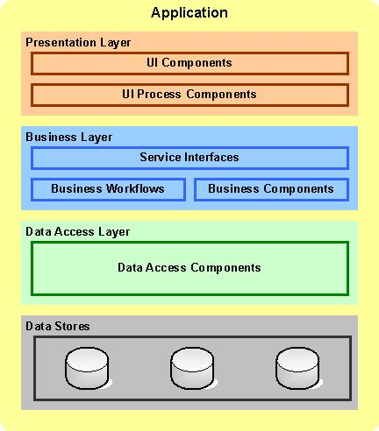

## Component inventory

# 

# Database Design

## Data Model

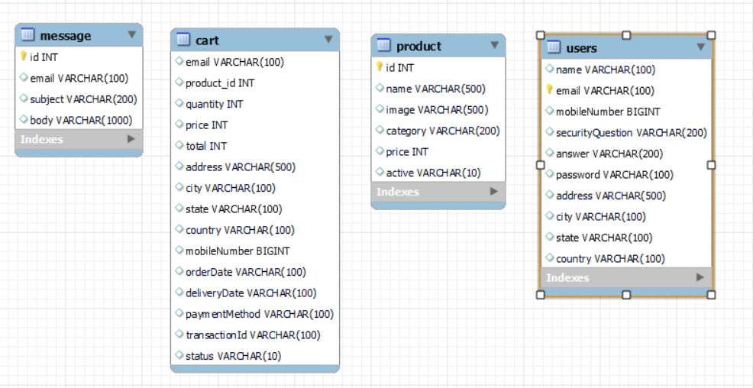

## Tables Structure

This project consists of 4 tables.

**1. CART TABLE**

|  |  |  |  |
| --- | --- | --- | --- |
| **Column Name** | **Data Type** | **Length** | **Nulls** |
| email | VARCHAR | 50 | NOT NULL |
| product_id | INT | 100 | NOT NULL |
| quantity | INT | 50 | NOT NULL |
| price | INT | 20 | NOT NULL |
| total | INT | 10 | NOT NULL |
| address | VARCHAR | 500 | NOT NULL |
| city | VARCHAR | 100 | NOT NULL |
| state | VARCHAR | 100 | NOT NULL |
| country | VARCHAR | 100 | NOT NULL |
| mobilenumber | VARCHAR | 100 | NOT NULL |
| orderDate | VARCHAR | 100 | NOT NULL |
| deliveryDate | VARCHAR | 100 | NOT NULL |
| paymentMethod | VARCHAR | 100 | NOT NULL |
| transactionId | VARCHAR | 100 | NOT NULL |
| status | VARCHAR | 100 | NOT NULL |

**2. MESSAGE TABLE**

|  |  |  |  |
| --- | --- | --- | --- |
| **Column Name** | **Data Type** | **Length** | **Nulls** |
| id | INT AI PK | 100 | NOT NULL |
| email | VARCHAR | 100 | NOT NULL |
| subject | VARCHAR | 200 | NOT NULL |
| body | VARCHAR | 500 | NOT NULL |

**3. PRODUCTS TABLE**

|  |  |  |  |
| --- | --- | --- | --- |
| **Column Name** | **Data Type** | **Length** | **Nulls** |
| id | INT | 50 | NOT NULL |
| name | VARCHAR | 500 | NOT NULL |
| image | VARCHAR | 500 | NOT NULL |
| category | VARCHAR | 200 | NOT NULL |
| price | INT | 20 | NOT NULL |
| active | VARCHAR | 10 | NOT NULL |
| id | INT | 255 | NOT NULL |

**4. USERS TABLE**

|  |  |  |  |
| --- | --- | --- | --- |
| **Column Name** | **Data Type** | **Length** | **Nulls** |
| name | VARCHAR | 30 | NOT NULL |
| email | VARCHAR PK | 100 | NOT NULL |
| mobileNumber | BIGINT | 10 | NOT NULL |
| securityQuestion | VARCHAR | 200 | NOT NULL |
| answer | VARCHAR | 200 | NOT NULL |
| password | VARCHAR | 20 | NOT NULL |
| address | VARCHAR | 255 | NOT NULL |
| city | VARCHAR | 100 | NOT NULL |
| state | VARCHAR | 30 | NOT NULL |
| country | VARCHAR | 20 | NOT NULL |

# Appendices

## Glossary

|  |  |
| --- | --- |
| **Acronyms** | **Definitions** |
| N. A | N. A |

## Other

# Terms & Conditions

***Disclaimer: Please do not circulate or distribute this document outside of Cognizant Network, We have a Zero Tolerance Policy. Kindly adhere to 100% Compliance at all times.***

# Change Log

*Please note that this table needs to be maintained even if a Configuration Management tool is used.*

|  |  |  |  |  |
| --- | --- | --- | --- | --- |
| Version Number | Changes made | | | |
| V<n.n> | *<If the change details are not explicitly documented in the table below, reference should be provided here>* | | | |
| Page no | Changed by | Effective date | Changes effected |
|  |  |  |  |
|  |  |  |  |
|  |  |  |  |
|  |  |  |  |